Answers

Task 1

1. How many bytes are there in:
(a) 3 kiB? 3 x 1024 = 3 072
(b) 2.5 MiB? 2.5 x 1024 x 1024 = 2 621 440
(c) 2 GiB? 2 x 1024 x 1024 x 1024 = 2 147 483 648
(d) 4 kib? 4 x 1024 / 8 = 512 bytes

2. For each of the binary values below, write down the denary equivalent. Use the grid below to help you.

(a) 1101 13
(b) 1111 15
(c) 00100110 38
(d) 10110111 183

128 | 64 | 32 | 16 | 8 | 4 | 2 | 1
 |  |  |  | 1 | 1 | 0 | 1
 |  |  |  | 1 | 1 | 1 | 1
0 | 0 | 1 | 0 | 0 | 1 | 1 | 0
1 | 0 | 1 | 1 | 0 | 1 | 1 | 1

3. What binary value is represented by the switches in the following circuit? 0110 0001
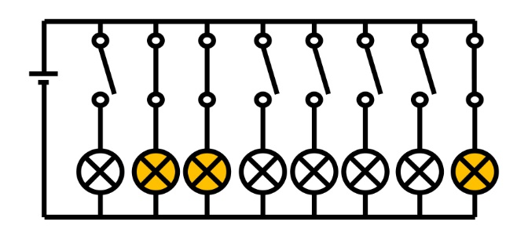

4. For the binary number 0110 1101, what is the value stored in:
(a) the most significant bit? 0 (the furthest left)
(b) the least significant bit? 1 (the furthest right)

Task 2

1. For each of the denary values below, write down the binary equivalent.
(a) 18 00010010
(b) 57 00111001
(c) 163 10100011
(d) 255 11111111
When converting from denary to binary, leading zeros do not need to be written. So (a) would be just as correct to write 10010.
However, if the question asks for an 8 bit number, then only 00010010 would be correct.

2. How many bytes would be needed to store the number 256?
Two bytes would be required to store the number 256.

Task 3

The questions below use 16 bits. Complete the place value headings in the grid for the 10th-16th bits. Then convert the following binary numbers to denary.
(a) 0001 1100 0111 0001 7,281
(b) 0010 0110 0010 0110 9,766
(c) 1111 1111 1111 1111 65,535
32768 | 16384 | 8192 | 4096 | 2048 | 1024 | 512 | 256 | 128 | 64 | 32 | 16 | 8 | 4 | 2 | 1
(d) Convert 19,675 to binary using the table below:
32768 | 16384 | 8192 | 4096 | 2048 | 1024 | 512 | 256 | 128 | 64 | 32 | 16 | 8 | 4 | 2 | 1
0 | 1 | 0 | 0 | 1 | 1 | 0 | 0 | 1 | 1 | 0 | 1 | 1 | 0 | 1 | 1

2. For each of the binary values below, write down the denary equivalent. Use the grid below to help you.
(a) 1 1011 1001 441
(b) 1011 0010 1010 2858
(c) 1001 1101 1110 1001 40425
(d) 1110 0101 1100 0001 58817

3. For each of the denary values below, write down the binary equivalent.
(a) 152 109 0001 0010 0010 1101
(b) 18 325 0100 0111 1001 0101
(c) 56 603 1101 1101 0001 1011
(d) 65 535 1111 1111 1111 1111

Task 4

Fill in the blanks using the words beneath to complete the following paragraph.
A CPU is made from a huge number of logic gates. These are used to process data. Each CPU will have a number of registers. Each one will store binary data. When a calculation (processing) occurs, the results will also be stored in a register.
Registers Process Logic gates Binary data CPU

